**ACS Below Wing**

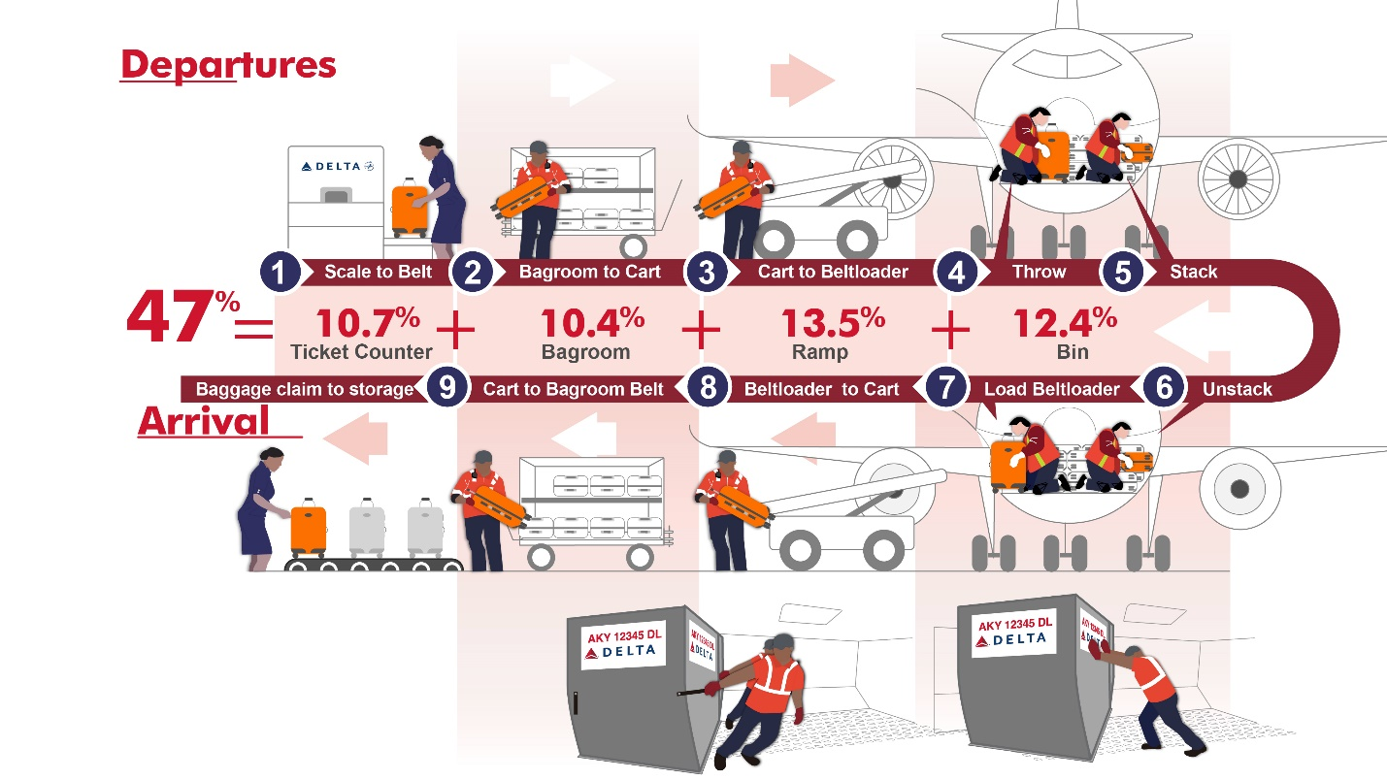

**ACS Cargo**

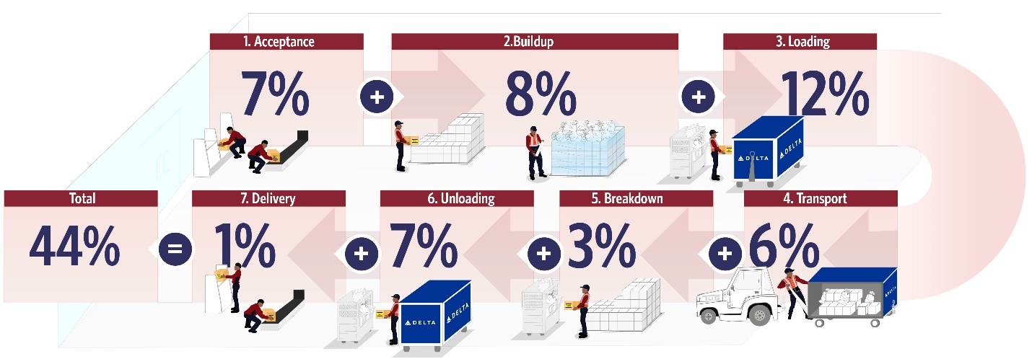

*Numbers are representing the percentage of injuries at the different steps or “touches” during the operation process.